**Independent Theatre Movement**

The Independent Theatre Movement in Europe was a primary shaping influence on modern dramatic literature and theatrical modernism.These small independent theatres were committed to freeing theatre and drama from the limitations of prevailing conventions, commercial considerations, and censorship.

The movement had its genesis in 1887 when André Antoine founded the Théâtre Libre in Paris. Most of the independent theatres operated on a subscription basis and were thus able to circumvent the censors. Antoine’s theatre was the model for most of the others, including the Freie Bühne in Berlin, founded in 1889 and operating under the leadership of Otto Brahm, and the Independent Theatre Society in London, founded in 1891 by the Dutch impresario J.T. Grein.

Due to the independent theatres, many of the most outstanding of the first generation of modernist playwrights were able to get their work produced, including Henrik Ibsen, August Strindberg, Gerhart Hauptmann, and Maurice Maeterlinck. Likewise, George Bernard Shaw made his debut with *Widowers’ Houses* in 1892 at Grein’s Independent Theatre.

While the independent theatres were largely committed to an aesthetic of naturalism—the first avant-garde—the Théâtre de l'Œuvre was primarily committed to symbolism. It was founded in 1892 by Aurélien Lugné-Poe, formerly an actor at the Théâtre Libre. Alfred Jarry’s *Ubu Roi* opened at the Théâtre de l'Œuvre in 1896.

Perhaps the most influential of the independent theatres in Europe was the Moscow Art Theatre (MAT), founded in 1897 by Vladimir Nemirovich-Danchenko and Konstantin Stanislavsky. Psychological realism was scrupulously explored at the MAT and ultimately developed into Stanislavky’s ‘System,’ which was worked out in the studio theatres of the MAT. The MAT was closely associated with the work of Anton Chekhov, whose first masterpiece, *The Seagull,* was successfully produced there in 1898. After the play’s initial failure at the Alexandra Theatre in St. Petersburg in 1896, Chekhov had sworn off writing plays, but changed his mind after the MAT’s success. *Uncle Vanya* (1899), *Three Sisters* (1901), and *The Cherry Orchard* (1904) were all first performed at the MAT, and their revolutionary construction led Stanislavsky to develop his acting system.

The Independent Theatre Movement was the model for the Little Theatre Movement in the United States and was in fact, as Edward Braun has written, ‘the prototype of all the free, independent, art, studio, basement, fringe, and lunchtime theatres, which have since initiated most of the advances of any consequence in twentieth-century drama’ (26). Its influence can still be felt Off-Off Broadway and in small experimental theatres in Europe and the United States.

**References and Further Reading**

Antoine, André. (1964) *Memories of the Théâtre Libre*, trans. Marvin A. Carlson, Coral Gables: University of Miami Press.

Braun, Edward. (1982) *The Director and the Stage: From Naturalism to Grotowski*, London: Methuen.

Brockett, Oscar G., and Robert Findlay. (1991) *Century of Innovation: A History of European and American Theatre and Drama since the Late Nineteenth Century*, Boston: Allyn and Bacon.

# Henderson, John A. (1971) *The First Avant-garde, 1887-1894*: *Sources of the Modern French Theatre*, London, G. G. Harrap.

# Magarshack, David. (1986) *Stanislavsky: A Life*, New York: Faber and Faber.

# Shattuck, Roger. (1968) *The Banquet Years: The Origins of the Avant-garde in France—1885 to World War I*, New York: Vintage.

**Matthew Yde, The Ohio State University**

**Recommended Illustrations**

**[Note: Please use all the recommended illustrations if possible. If all are not possible, please make the images of *The Wild Duck* and *The Weavers* a lower priority because the quality of the images is not quite as good as the others. But please try to use all to illustrate this important modernist movement.]**

C:\Users\farfan\AppData\Local\Temp\cas790-1.tif

**Sketch of Ibsen’s *The Wild Duck*, Théâtre Libre, 1891.**

[Available at Hekman Digital Archive, Calvin College: <http://library.calvin.edu/hda/sites/default/files/cas790h.jpg>]

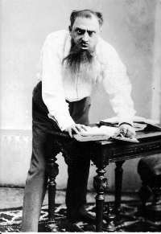

**Emanuel Reicher in August Strindberg’s *The Father*, Freie Bühne, 1890.**

[Available at the Strindberg Museum: <http://www.strindbergsmuseet.se/verken2.html> ]

C:\Users\farfan\AppData\Local\Temp\cas788.tif

**Gerhart Hauptmann’s *The Weavers*, Théâtre Libre, 1893.**

[Available at Hekman Digital Archive, Calvin College: <http://library.calvin.edu/hda/node/2077>]

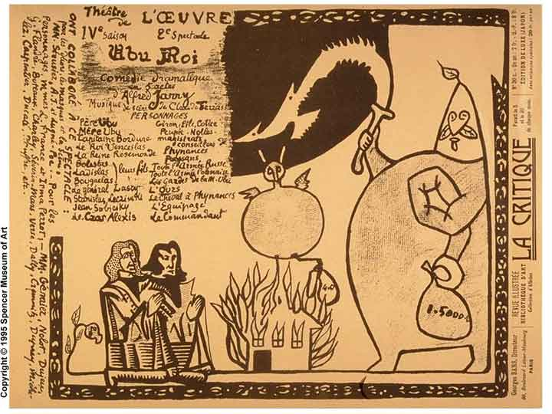

**Alfred Jarry’s poster design for *Ubu Roi*, 1896.**

[Available at: <http://www.nytimes.com/imagepages/2006/05/19/arts/19fren_ready.html> AND <http://www.spencerart.ku.edu/exhibitions/radicalism/jarry.shtml> AND <http://www2.newpaltz.edu/~paparonj/SPRING/Image64.jpg> ]

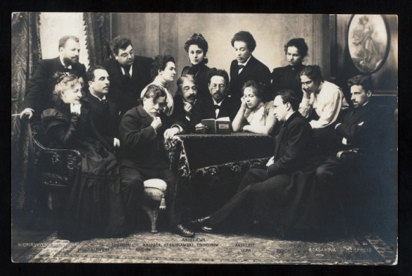

**Anton Chekhov (centre) reading *The Sea Gull* to the Moscow Art Theatre company, including Vladimir Nemirovich-Danchenko (standing, far left), Konstantin Stanislavsky (sitting beside Chekhov), and Vsevolod Meyerhold (sitting, far right).**

[Available at Billy Rose Theatre Collection, New York Public Library, Digital Gallery: <http://digitalgallery.nypl.org/nypldigital/id?th-38307>]

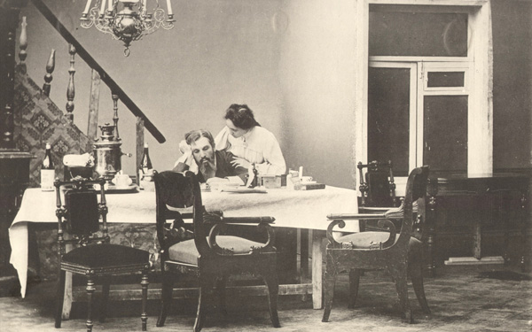

**Chekhov’s *Uncle Vanya*, Moscow Art Theatre, 1899.**

[Available at: http://theredlist.com/media/database/settings/performing-art/topics/rooms/003-set-design-room-theredlist.jpg]